The Registrar,
National Institute of Technology,
Hazratbal, Srinagar.

No: KGP/Estt/2025/664 Dated:21-07-2025

Subject: Submission of Machinery and Equipment Details and Syllabuses for Strengthening the Technical Education Infrastructure of Kashmir Government Polytechnic College, Srinagar.

Sir,
With reference to this office letter no. KGP/Estt/2025/491, dated 30-06-2025, and following the visit of the Heads of Departments (HODs) from our institution, we have provided the soft copy details of the machinery and equipment proposed for procurement for various branches of our institution. The soft copy of the proposed machinery and equipment is accessible via the Google Sheet link: https://docs.google.com/spreadsheets/d/1iNZzmsl9idQKKPVl_J46GRd_bxgDtscn/edit?gid=246009231#gid=246009231 .
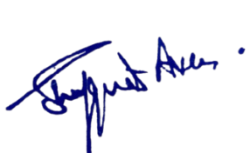
Additionally, a copy of the syllabi for the relevant departments has been provided for your reference. We kindly request you to support by forwarding the same to the Departmental Heads at your institution to review, modify, add, update, or delete the machinery and equipment details as necessary. These details are critical to our procurement strategy and will form the foundation for onward submission to the Office of the Administrative Secretary, Department of Skill Development, for review and approval. Given the urgency and critical importance of this initiative, we earnestly solicit your timely response to facilitate further action. Thank you for your cooperation and support. For any coordination, kindly contact Er. Ali Mohd Khan, HOD ECE on 7006406972.

Principal
Kashmir Government Polytechnic College
Srinagar

